Exploring Hypermobile Wellbeing: Methodologies for Practicing with Ehlers Danlos Disorder
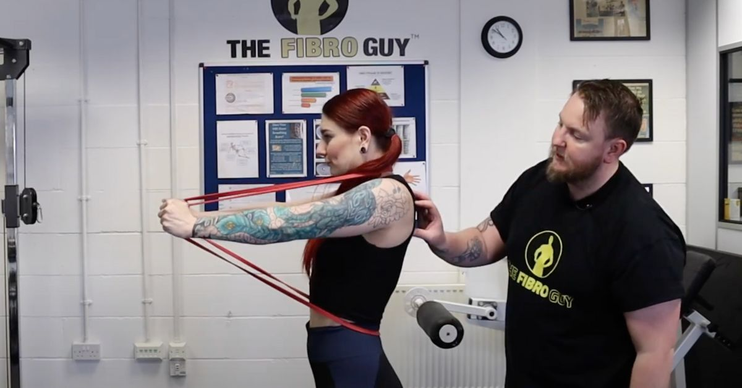
In the domain of wellbeing and health, exploring the intricacies of conditions like Ehlers Danlos Disorder (EDS) and hypermobility requests a nuanced approach.
People with hypermobility frequently face one of a kind difficulties with regards to exercise and restoration. Notwithstanding, with customized procedures and a far reaching comprehension of their condition, they can set out on an excursion towards worked on prosperity.

Practicing with Ehlers Danlos Condition requires a fragile harmony between remaining dynamic and forestalling injury. For those new, EDS is a connective tissue problem portrayed by joint hypermobility, skin delicacy, and tissue shortcoming. This condition influences people in an unexpected way, with side effects going from gentle to extreme. Accordingly, customized care and direction are fundamental.

Hypermobility Recovery is a specific field that Exercising with Ehlers Danlos Syndrome exercising with hypermobility spotlights on tending to the exceptional necessities of people with hypermobility disorders. Through designated activities and mediations, restoration experts plan to work on joint dependability, solid strength, and utilitarian versatility. These intercessions might incorporate reinforcing works out, proprioceptive preparation, and joint adjustment procedures.

Athttps://www.thefibroguy.com, we represent considerable authority in giving extensive restoration administrations to people with hypermobility conditions like Ehlers Danlos Disorder. Our group of experienced experts comprehends the difficulties related with hypermobility and is devoted to assisting clients with accomplishing their wellbeing and wellness objectives.

Integrating exercise into one's normal can be especially helpful for people with hypermobility and chemical imbalance.
Research proposes a likely connection between chemical imbalance range problems (ASD) and joint hypermobility. While the specific idea of this relationship stays being scrutinized, practice has been displayed to affect both physical and mental prosperity in people with ASD decidedly.

While creating an activity routine for people with EDS or hypermobility, focusing on security and sustainability is fundamental.
Low-influence exercises like swimming, cycling, and yoga can give the advantages of activity without overburdening weak joints. Furthermore, consolidating opposition preparing can assist with working on solid strength and joint steadiness.

It's urgent for people with hypermobility to work intimately with medical care experts, including physiotherapists and exercise physiologists, to foster a customized practice plan.

This plan ought to consider individual necessities, objectives, and restrictions. Moreover, paying attention to one's body and taking on a steady speed are key standards in overseeing EDS and hypermobility.

All in all, practicing with Ehlers Danlos Disorder and hypermobility requires a smart and individualized approach. By working with proficient experts and taking on protected and maintainable activity rehearses, people can improve their personal satisfaction and relieve the effect of their condition.

Keep in mind, progress might be continuous, yet every step towards further developed wellbeing is critical.
Visit our site to look into our particular administrations for hypermobility recovery and how we can uphold you on your excursion to better wellbeing.

